**ICON PROJECT**

**Coding Plan**

Notes: icon exists as .csv file of 0’s, 1’s; is primitive key logo; 10x10, not perfectly centered or symmetrical.

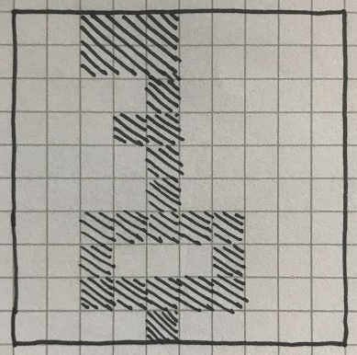

**FUNCTIONS**

read_in_icon()

Opens csv

Creates dict from csv rows

Keys are 1-10

Values are lists of 0’s, 1’s

print_icon()

Read key/values pairs

Print lists (values) as graphic/icon

Transform 0’s to spaces, 1’s to symbol (@, #, etc.)

New line after each row

transform_icon()

Scaling is probably easiest - double each 0, 1, in each row and then duplicate the doubled rows.

Rotate 90/180 seems a lot harder

Invert Colors seems pretty easy

Mirroring is probably doable